**Module 10 – Single Page Application framework – React**

**12.ReactJS-HOL**

**1. Explain about Conditional Rendering in React**

Conditional rendering in React means showing or hiding parts of the user interface based on certain conditions.

For example, we can display a **"Login"** page for users who are not logged in, and a **"Dashboard"** page once they log in. It works just like if, else, or switch statements in JavaScript, but inside JSX.

We can use:

* if / else statements
* ternary operators (condition ? true : false)
* logical && to show something only if a condition is true

Conditional rendering helps in building dynamic and interactive web apps.

**2. Define Element Variables**

In React, we can store JSX (HTML-like code) inside a variable and use it later in the return() statement. These are called **element variables**.

This helps make our code cleaner and easier to understand, especially when we have multiple conditions.

**Example**:

let page;

if (isLoggedIn) {

page = <UserPage />;

} else {

page = <GuestPage />;

}

return (

<div>

{page}

</div>

);

Element variables are useful for storing and switching components before rendering them.

**3. Explain How to Prevent Components from Rendering**

Sometimes, we may not want to render (show) a component at all. In such cases, we can simply return null from the component.

When a component returns null, React skips rendering it — meaning nothing will be shown on the screen for that part.

🔸 **Example**:

function Warning(props) {

if (!props.showWarning) {

return null;

}

return <p>Warning!</p>;

}

**Structure:**

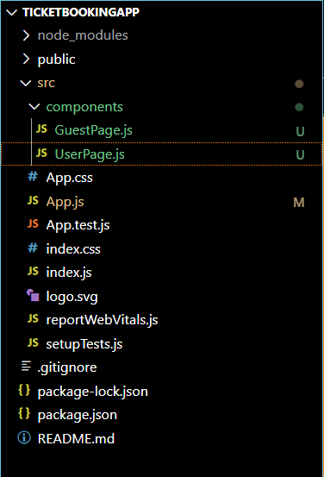

**GuestPage.js:**

import React from 'react';

const GuestPage = ({ onLogin }) => {

  return (

    <div>

      <h2>Welcome, Guest!</h2>

      <p>You can browse available flights, but only registered users can book tickets.</p>

      <h3>✈️ Available Flights</h3>

      <ul>

        <li>Chennai → Delhi — 10:00 AM</li>

        <li>Bangalore → Mumbai — 2:00 PM</li>

        <li>Hyderabad → Kolkata — 6:30 PM</li>

      </ul>

      <button onClick={onLogin}>Login</button>

    </div>

  );

};

export default GuestPage;

**UserPage.js:**

import React from 'react';

const UserPage = ({ onLogout }) => {

  return (

    <div>

      <h2>Welcome, User!</h2>

      <p>You are logged in. You can now book tickets.</p>

      <h3>🛫 Book Your Flight</h3>

      <ul>

        <li>

          Chennai → Delhi <button>Book</button>

        </li>

        <li>

          Bangalore → Mumbai <button>Book</button>

        </li>

        <li>

          Hyderabad → Kolkata <button>Book</button>

        </li>

      </ul>

      <button onClick={onLogout} style={{ marginTop: '20px' }}>Logout</button>

    </div>

  );

};

export default UserPage;

**Output:**

